RDBMS ASSIGNMENT- WEEK 7
PROGRAM USING SUM
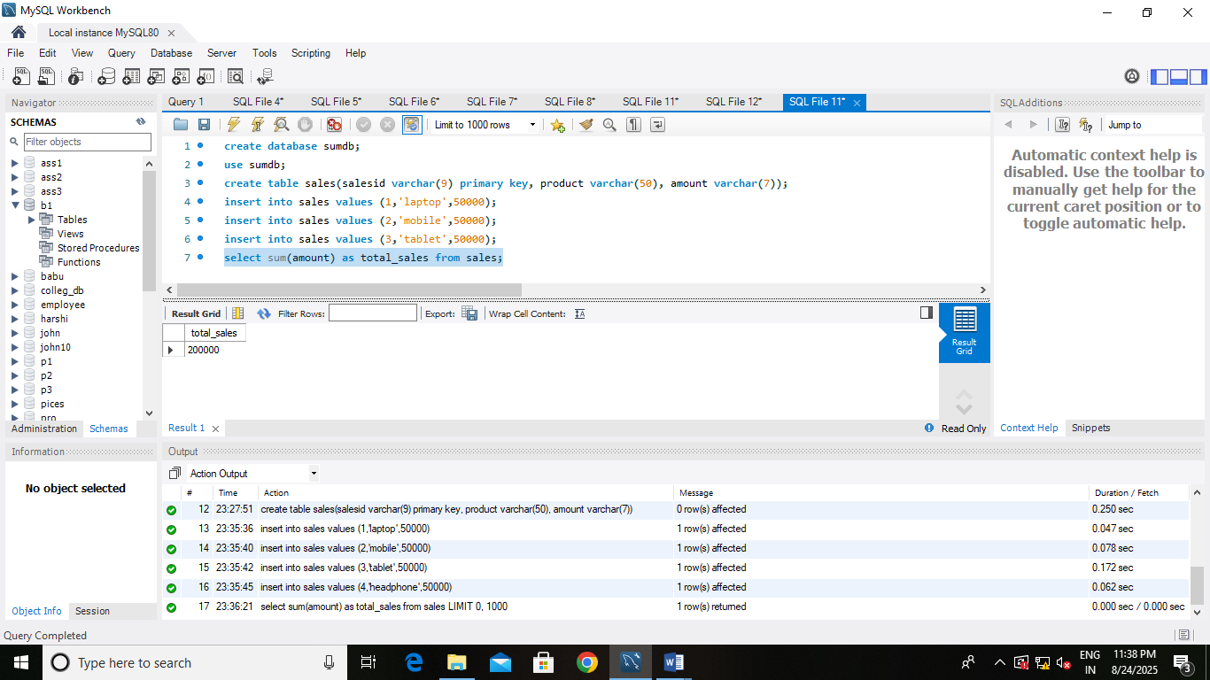

( PROGRAM USING AVG)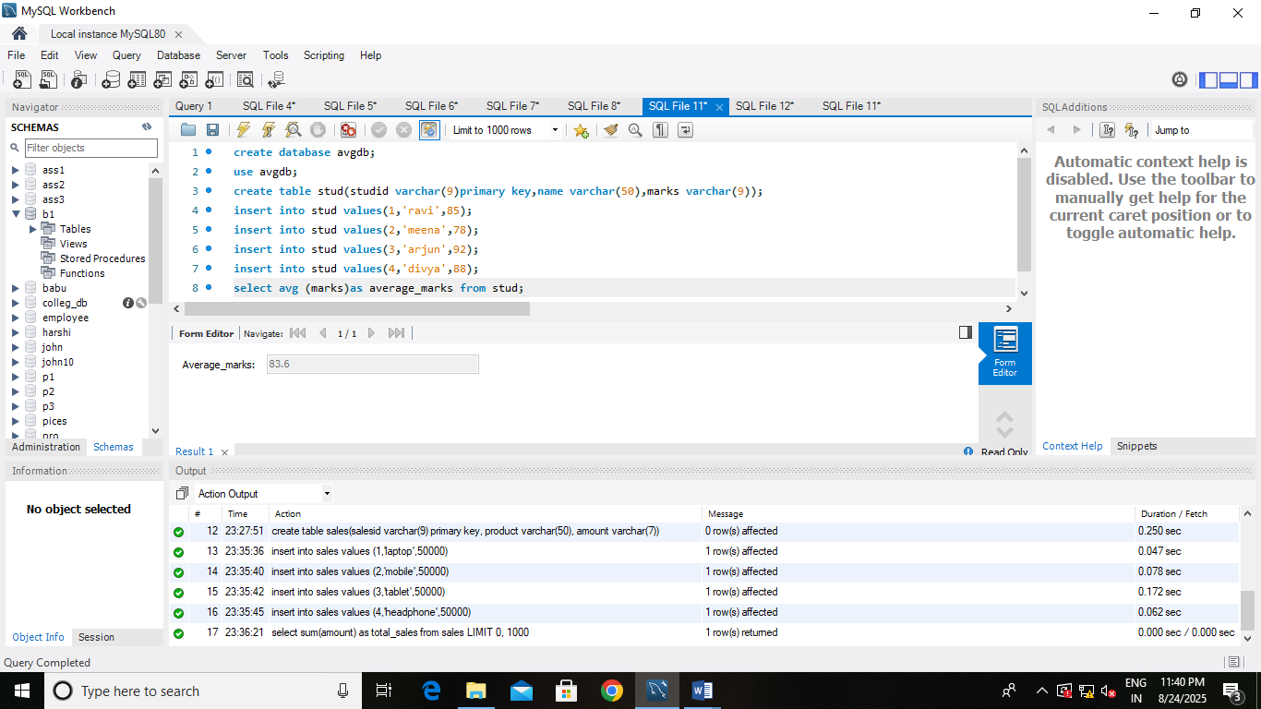

PROGRAM USING COUNT